Transition Out Plan
LitPath AI: Smart Pathfinder for Theses and Dissertations

Asia Pacific College
3 Humabon, Magallanes
Makati City, Metro Manila 1232

May 2026

Table of Contents
1. Executive Summary 3
2. Transition Approach 3
3. Transition Team Organization 4
4. Workforce Transition 5
5. Work Execution During Transition 5
6. Subcontracts 6
7. Property Transition 6
7.1. Government Furnished Equipment (GFE) 6
7.2. Incumbent Owned Equipment 7
7.3. Intellectual Property 7
7.4. User Accounts and Passwords 7
8. Knowledge Transfer 8
9. Schedule 8
10. Handover and Acceptance 9

Executive Summary
The purpose of the executive summary is to describe the transition plan at a high level and what the plan should accomplish. This section should include an overview and history of the contract, who the contract is currently with, who it is transitioning to, and the timeframe/period of transition.

This plan formally documents the transition of the LitPath AI system, deliverables, documentation, and operational responsibilities from team HecTech to the DOST-STII Library. LitPath AI is an AI-powered web application designed to replace the library’s existing keyword-based OPAC search with a semantic search system powered by Retrieval-Augmented Generation (RAG) and Gemini AI. Following successful User Acceptance Testing and transition activities, full ownership, hosting, maintenance, and operational responsibility for the system will transfer permanently to DOST-STII.

Transition Approach
This section of the contract transition out plan discusses the overall approach to the transition. Some items which must be considered are: will you scale down your staff during the transition or will you bring in additional staff to handle and manage the transition? How long is the transition? What are your assumptions (i.e. the staff of the new contractor will be available onsite to participate in the transition and receive knowledge transfer, etc.)?

For this transition, HecTech will maintain its existing four-member team throughout the transition period to support knowledge transfer, system walkthroughs, and issue resolution. No additional staffing requirements are anticipated. The transition is expected to take 1 day following LitPath AI’s successful User Acceptance Testing and will be conducted onsite at DOST-STII Library. HecTech will initiate transition activities upon achieving an average user satisfaction score of at least 3.5 out of 5 from the test group of students and DOST employees. It is assumed that DOST-STII will assign designated representatives to coordinate walkthroughs and documentation acceptance during the transition period.

Transition Team Organization
This section of the transition out plan should provide an organizational chart showing all resources and their roles in the transition (i.e. Transition Project Manager, etc.). Key team members should be from both the incumbent and new contractors as well as the customer.

The following table illustrates the transition team members from HecTech and DOST-STII, along with the roles and responsibilities of each member throughout the transition period.

Organization | Title | Roles/Responsibilities
DOST-STII | Client Representative | Coordinate transition activities with HecTech; receive and review all system documentation and deliverables; provide formal institutional acceptance of the system at transition completion
DOST-STII | End User Representative | Participate in system walkthrough and user acceptance demonstration; provide feedback on usability and functionality during the transition period
HecTech | Project Manager | Chair all transition activities conducted onsite; coordinate and schedule all handover activities; track completion of the transition checklist; provide transition status updates to the Project Sponsor; ensure all deliverables are submitted and accepted
HecTech | Backend Developer | Conduct technical system walkthroughs covering the RAG pipeline, ChromaDB vector search, Supabase database, and Gemini AI integration; transfer all backend architecture documentation and production credentials
HecTech | Frontend Developer | Conduct user interface walkthroughs for all system features including search, AI overview display, citation generation, and bookmarking;
HecTech | DevOps Engineer | Confirm completion of all security controls and compliance requirements under RA 10173; conduct final system security review; hand over all QA test reports, test cases, and security audit documentation; support DOST-STII in configuring role-based access for admin accounts

Workforce Transition

It is not uncommon for the workforce to transition from one contractor to another as part of the contract transition. The workforce may stay in place with the client or customer and simply “re-badge” from the incumbent to the new contractor. It is also common for the incumbent workforce to leave the site once the transition is completed and approved. In order to set expectations and allow for adequate transition planning, the workforce must be determined and communicated ahead of time.

For this project transition, all HecTech team members will be present onsite at DOST-STII Library on the day of transition to complete their assigned handover activities. Upon formal acceptance by the Project Sponsor and completion of all training and documentation handover activities, HecTech's involvement with the LitPath AI project will conclude immediately and permanently. As HecTech is a student development team, no workforce continuity or ongoing operational role is assumed after handover. DOST-STII will designate at least one system administrator to receive administrative access, technical documentation, and system training on the day of transition, and this individual will be solely responsible for all system operations from that point forward.

Work Execution During Transition
Discuss the level of work which is to be performed during the transition period and the impact of the transition on that work (i.e. system maintenance, software development, support services, etc.).

On the day of transition, the LitPath AI system will be fully deployed and operational on Proxmox server and accessible outside Asia Pacific College campus, having passed User Acceptance Testing with an average satisfaction score of at least 3.5 out of 5. All knowledge transfer sessions, system walkthroughs, and documentation handover will be completed onsite on the transition day. HecTech will deliver the system in a stable, defect-free state and will not be responsible for resolving any issues that arise on DOST-STII's side after the transition is formally accepted and closed. Upon completion of training and documentation handover, HecTech will be fully hands-off, and full operational responsibility including maintenance, troubleshooting, and any future enhancements will rest entirely with DOST-STII.

Subcontracts
This section documents all the existing contracts and if/how they will be transitioned. It should contain this information in a table format (subcontract agreements, software/hardware maintenance contracts, etc.).

The LitPath AI project was developed entirely by the HecTech team with no subcontractors or third-party development engagements. However, the system relies on the following third-party services and platforms that must be acknowledged as part of the transition:

Service / Platform | Provider | Purpose
Gemini AI API | Google AI Studio | Semantic query understanding, AI-generated research overviews, result re-ranking
Supabase | Supabase Inc. | PostgreSQL relational database for user accounts, bookmarks, document metadata, etc.
SentenceTransformers | Hugging Face | Embedding generation for RAG pipeline
Production Hosting Environment | DOST-STII (cloud) | Host and serve the LitPath AI application

Property Transition

Institution Furnished Equipment (GFE)
This section of the plan describes the transition of any equipment for a scenario where the customer is a government entity and provides the contractor with government property. This property may include hardware such as laptops/PCs, software bundles or add-ons, portable electronic devices (PEDs), and security badges. Typically, GFE will be turned back over to the government customer during a transition and may or may not be re-issued to the new contractor.

No institution-furnished equipment was provided to HecTech for the development of LitPath AI. All development hardware was sourced and maintained by HecTech. The DOST-STII production hosting environment, managed by DOST-STII, will serve as the operational infrastructure for post-transition. HecTech will provide all necessary deployment documentation to support maintenance of this environment.

HecTech Owned Equipment
Equipment owned by the incumbent contractor will usually remain with them when they transition off of the contract. However, there may be instances where incumbent owned equipment supports customer applications and services. This section should state that incumbent owned equipment will remain with the incumbent - and identify options where this equipment may be available for purchase by the new contractor or customer for their use (i.e. application server and application for helpdesk, etc.).

All hardware utilized by HecTech during development will remain with the team. These assets are not required for the ongoing operation of the system. The complete LitPath AI codebase, database schemas, and embedding data will be fully migrated to the DOST-STII production environment, ensuring independent access post-transition.

Intellectual Property
Here the transition out plan should describe how intellectual property will be handled as part of the transfer process. Intellectual property may include various documentation, supplier and subcontractor information, service agreements, or original designs or plans. Intellectual property generates many legal considerations and may include the completion of non-disclosure agreements (NDAs) between the incumbent and the customer. Intellectual property may be transferred, sold, or retained by the incumbent depending on the contractual agreements in place.

All intellectual property resulting from the development of LitPath AI including the codebase, database schema, prompt configurations, and UI/UX designs will be transferred to DOST-STII. DOST-STII will hold full ownership of the deployed system and associated technical documentation upon transition completion. User data handling remains governed by the Data Privacy Act of 2012 (RA 10173).

User Accounts and Passwords
This section of the transition plan should discuss how any accounts will be transitioned, who they will be transitioned to (i.e. system administrator accounts). Provide a table of all user accounts to be transitioned/disabled.

Administrative credentials will be transferred and secured in accordance with system architecture and RA 10173 requirements. HecTech development-environment accounts will be deactivated upon completion.

User Account | Current Holder | Transferred To
Gemini AI API Key | HecTech | DOST-STII System Administrator
Supabase Project | HecTech | DOST-STII System Administrator
GitHub Repository Access | HecTech | DOST-STII System Administrator
System Admin Account | HecTech | DOST-STII System Administrator

Knowledge Transfer
This section should discuss how knowledge will be transferred from the incumbent staff to the staff of the new contractor (documentation/instruction manuals including as-built documents, formal training classes, one-on-one training/knowledge transfer, etc.). This is an important consideration as the transfer of knowledge is what provides continuity for the contract.

For this transition, knowledge transfer will be conducted onsite at the DOST-STII Library through structured walkthroughs, documentation handover, and support sessions coordinated by the Project Manager.

The Backend Developer will conduct technical walkthroughs covering the system architecture, RAG pipeline, databases, API integrations, deployment, and credential transfer. The Frontend Developer will conduct user-facing walkthroughs of core features such as semantic search, AI-generated overviews, citation generation, and bookmarking. The DevOps Engineer will conduct sessions covering security, role-based access, compliance measures, deployment configuration, and user account management.

All system documentation and test reports will be handed over upon completion of the transition activities, after which full operational responsibility for LitPath AI will transfer to DOST-STII.

Schedule
This section of the transition plan should contain a GANTT chart schedule of the transition. The complexity of the transition will dictate the level of detail required in the schedule. However, all major milestones as well as transition start and completion dates should be included at a minimum.

The following Gantt chart illustrates the schedule for the transition of the LitPath AI system from HecTech to DOST-STII. The transition is a single-day event conducted onsite at the DOST-STII Library on June 1, 2026, initiated upon confirmation that LitPath AI has achieved an average user satisfaction score of at least 3.5 out of 5 during User Acceptance Testing. Any changes to this schedule will require review and approval from the Project Sponsor.

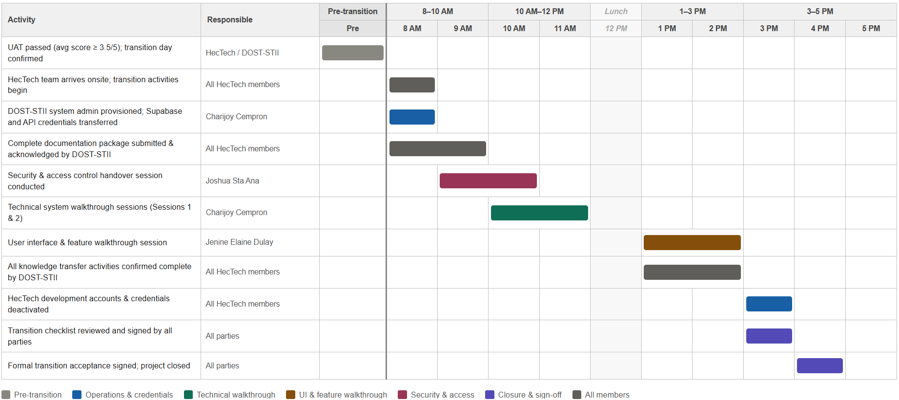

Handover and Acceptance
This section of the contract transition out plan should discuss how the customer will formally accept the handover at the end of the transition. This may include whether or not there’s a checklist for acceptance or formal sign-off. There are typically several people who need to accept the handover (i.e. security office for all badges, IT Manager for system accounts, Contracts Manager, etc.).

Formal handover and acceptance of the LitPath AI system will be determined by the completion of all transition checklist activities conducted onsite at DOST-STII Library on the transition day, as validated by the Project Sponsor. The Project Manager will track checklist completion throughout the day and confirm that all items are satisfied before presenting the formal acceptance document for signature.

Transition will be considered complete once all system documentation has been received and acknowledged by DOST-STII, all knowledge transfer and walkthrough sessions have been completed, all user accounts have been properly configured and HecTech development credentials deactivated, and the Proxmox deployment is confirmed stable and operational. The transition checklist must be signed by the DOST-STII Client Representative and the Project Sponsor before the formal acceptance document is presented.

Upon completion, a formal acceptance document will be signed by the HecTech Project Manager and the Project Sponsor. It is only after all signatures are obtained that the transition will be formally closed. The signed document will be archived in the project's shared document repository on SharePoint and submitted as part of the academic closure requirements at Asia Pacific College. From this point forward, HecTech carries no further responsibility for the LitPath AI system, and any issues arising on DOST-STII's side are solely DOST-STII's responsibility to resolve.

